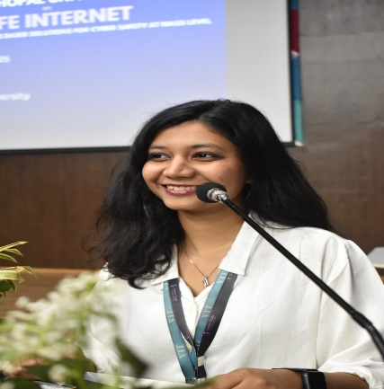

BHUVIKA

AGGARWAL

# INTERN

## PROFILE

* Seeking an internship to apply my skills in Backend development, Data Analyst, Python, PowerBI, Java, C++, SQL, HTML, and CSS.
* Experienced in project management and team collaboration, as demonstrated by my role as Outreach Lead for the Linux Club at VIT Bhopal University.
* Eager to learn and contribute to innovative projects.

## CONTACT

* **PHONE:** 9315907474
* **LINKEDIN**:
* https:/[/www.linkedin.com/in/bhuvika-](http://www.linkedin.com/in/bhuvika-) aggarwal-79656b251/
* **EMAIL**:

bhuvikaaggarwal372@gmail.com

* **ADDRESS**: FCA 3017A, Gali No 1, Block-A, SGM Nagar, NIT

Faridabad, Haryana-121001

## SKILLS

* Python
* PowerBI
* MongoDB
* Nodejs
* Data analyst
* AI\ML
* Java
* C++
* SQL
* HTML

## EDUCATION

**DAV PUBLIC SCHOOL**

2014 - 2022

SR. SECONDARY HIGH SCHOOL

**VELLORE INSTITUTE OF TECHNOLOGY**

2022 - 2026

GRADUATION

### EXPERIENCE

**Backend Developer Intern**

**SWET(Government Authorised) Paid Internship (Stipend: ₹70,000)**

* Currently working on the development of a national-level online examination portal for conducting Olympiads across schools in India.
* Responsible for designing and implementing backend services, including user authentication, exam scheduling, question paper generation, and result management using technologies such as Node.js, MongoDB, and Express.
* Contributed to data analysis tasks to assess user performance and generate insightful reports for academic evaluation.

Skills: Backend Development, Node.js, Express, MongoDB, REST APIs, Data Analysis, Team Collaboration, Basic Web Development.

**Outreach and Networking for Linux club**:

* As a PR and Outreach Lead, I Had Successfully reached out to various organizations for sponsorships and collaborations.
* Secured 130 headphones for a college fest event, partnership of Unstop, sponsorship for Red bull, givemycertificate, local Bhopal startup, anime Devta, silent owl, Boom Panda, Collage Rivals.

### EXPERIENTIAL LEARNING

* **Technical Skill Enhancement:** Attended a hands-on workshop on AI, ML, and Deep Learning, leveraging Intel DevCloud and drones for practical experience.
* **Industry Exposure:** Visited renowned organizations like ISRO, INCOIS, and Persistent Systems to gain insights into cutting-edge technologies and industry practices.
* **Entrepreneurial Insights:** Attended a seminar by industry experts Mr. Chetan Almelkar and Mr. Milind Datar, gaining valuable knowledge on entrepreneurship and innovation.

**CERTIFICATES**

Certification in AIML from Coursera

Vityarthi certificate of Computer vision

### PROJECTS

* Working on a database management project for Car Rental System.
* Worked on the end-to-end application for Fetal Health Detection System.
* Working as the backend developer for an online examination portal for conducting Olympiads.

### HOBBIES

* Dance
* Painting
* Singing
* Sports
* Art and Craft

### EXTRA-CURRICULAR ACTIVITIES

**Club Management:**

* Organized and managed events as Outreach Lead for Linux Club at VIT Bhopal University.
* Member of NULL community and fusion club.
* Organized and executed successful events, including a silent disco and capture the flag event.

**Academic Excellence:**

* Consistently ranked among the top 10 students in the class from 6th to 12th grade.
* Selected to visit Teen Murti Bhavan, a prestigious honor for academic achievement.

**Leadership and Teamwork:**

* Served as House Head, leading organizing house activities and parades.
* Collaborated effectively with team members to achieve successful outcomes in various competitions.

**Athletic Achievements:**

* Reached the semi-finals in the college badminton championship.
* Won gold medal in district-level skating competition.
* Participated in state-level throw ball competition.

**Artistic and Cultural Pursuits:**

* First-place winner in a 10th-grade talent hunt dance competition.
* Performed in various stage performances, including dance, singing, anchoring, and drama.
* Won awards in rangoli and clay pot painting competitions.